Data Flow Diagrams & User

Stories

Date: 08 Mar 2026
Team ID: SWTID-2026-1998
Project Name: [Micro Goal] Maximum Marks: 4

- Overview

  - Project Design Phase II
  - Data Flow Diagram & User Stories
  - Date: February 16, 2026
  - Project Name: [Enter Project Name]
  - Team ID: [Enter Team ID]
  - Micro Goal: [Enter Micro Goal]
  - Maximum Marks: 4

- Data Flow Diagram (DataFlowDiagrams)

  - Express.js HTTP Request Flow with MongoDB
  - Key Components:
    - Express Server
    - Routes
    - Middleware Layer
    - Auth Middleware
    - Error Middleware
    - Controllers
    - Models
    - MongoDB Database
    - JSONResponse
    - User

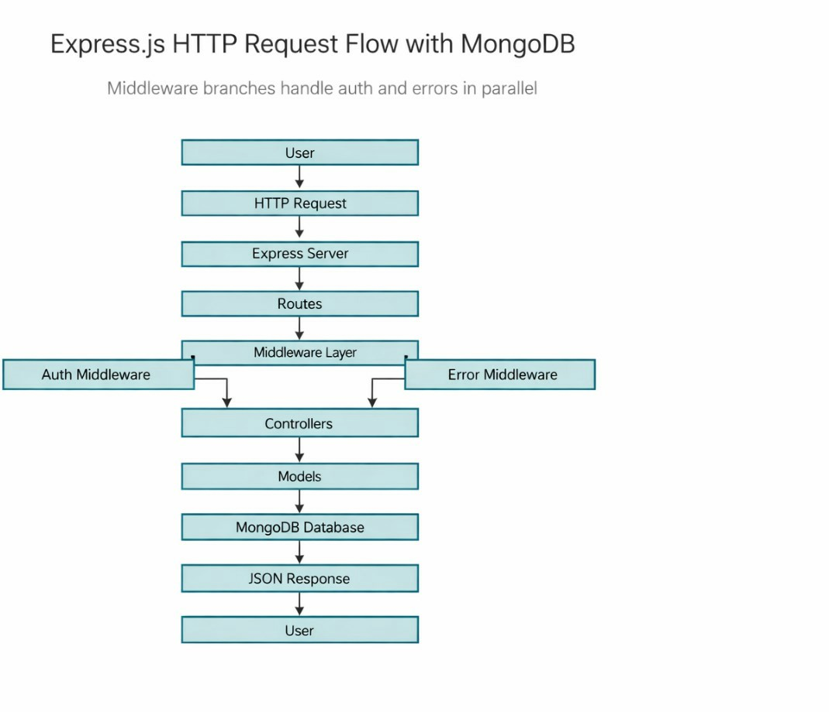

- User Stories – MicroGoals Backend API
User Type: Customer (Web User) and Developer/Admin

  - USN-1: Registration
    - As a user, I want to register an account so that I can access the system.
    - Acceptance: User data stored in the database; success response returned.
    - Priority: High
    - Release: Sprint-1

  - USN-2: Login
    - As a user, I want to log in securely so I can access my personal goals.
    - Acceptance: Valid email/password; JWT token; status 200.
    - Priority: High
    - Release: Sprint-1

  - USN-3: Create Goal
    - As a user, I want to create a new goal to manage my tasks.
    - Acceptance: Goal saved in database; 201 Created.
    - Priority: High
    - Release: Sprint-1

  - USN-4: View Goals
    - As a user, I want to view my goals to track progress.
    - Acceptance: Only authenticated users can access their own goals.
    - Priority: High

    - Release: Sprint-1

  - USN-5: Update Goal
    - As a user, I want to update an existing goal.
    - Acceptance: Updated goal saved in database.
    - Priority: High
    - Release: Sprint-1

  - USN-6: Delete Goal
    - As a user, I want to delete a goal.
    - Acceptance: Goal permanently deleted; success response.
    - Priority: High
    - Release: Sprint-1

  - USN-7: Data Protection
    - As a user, I want my data protected from other users.
    - Acceptance: Unauthorized access yields 401 error.
    - Priority: High
    - Release: Sprint-1

  - USN-8: API Testing
    - As a developer, I want to test API endpoints to ensure they work.
    - Acceptance: Correct responses and status codes in Thunder Client.
    - Priority: Medium
    - Release: Sprint-2

  - USN-9: Centralized Error Handling
    - As a developer, I want centralized error handling to manage errors efficiently.
    - Acceptance: Errors handled via middleware with proper messages.
    - Priority: Medium
    - Release: Sprint-2

- Acceptance Criteria & Priorities

  - USN-1 to USN-9 with the Acceptance Criteria and Priority as listed above.

- Middleware & Security

  - Auth Middleware
  - Error Middleware
  - Access Control
  - 401 Unauthorized handling

- API Testing

  - Tools: Thunder Client (as referenced)
  - Endpoints validation, status codes, and error handling expectations

- Data & Models

  - MongoDB Database
  - Controllers
  - Models
  - JSONResponse format

- Conclusion

  - Summary: This document captures the backend API goals, data flow, and middleware design for Sprint-1 and Sprint-2.
  - Next Steps: Implement endpoints, wire up middleware, write tests, and validate with Thunder Client.

